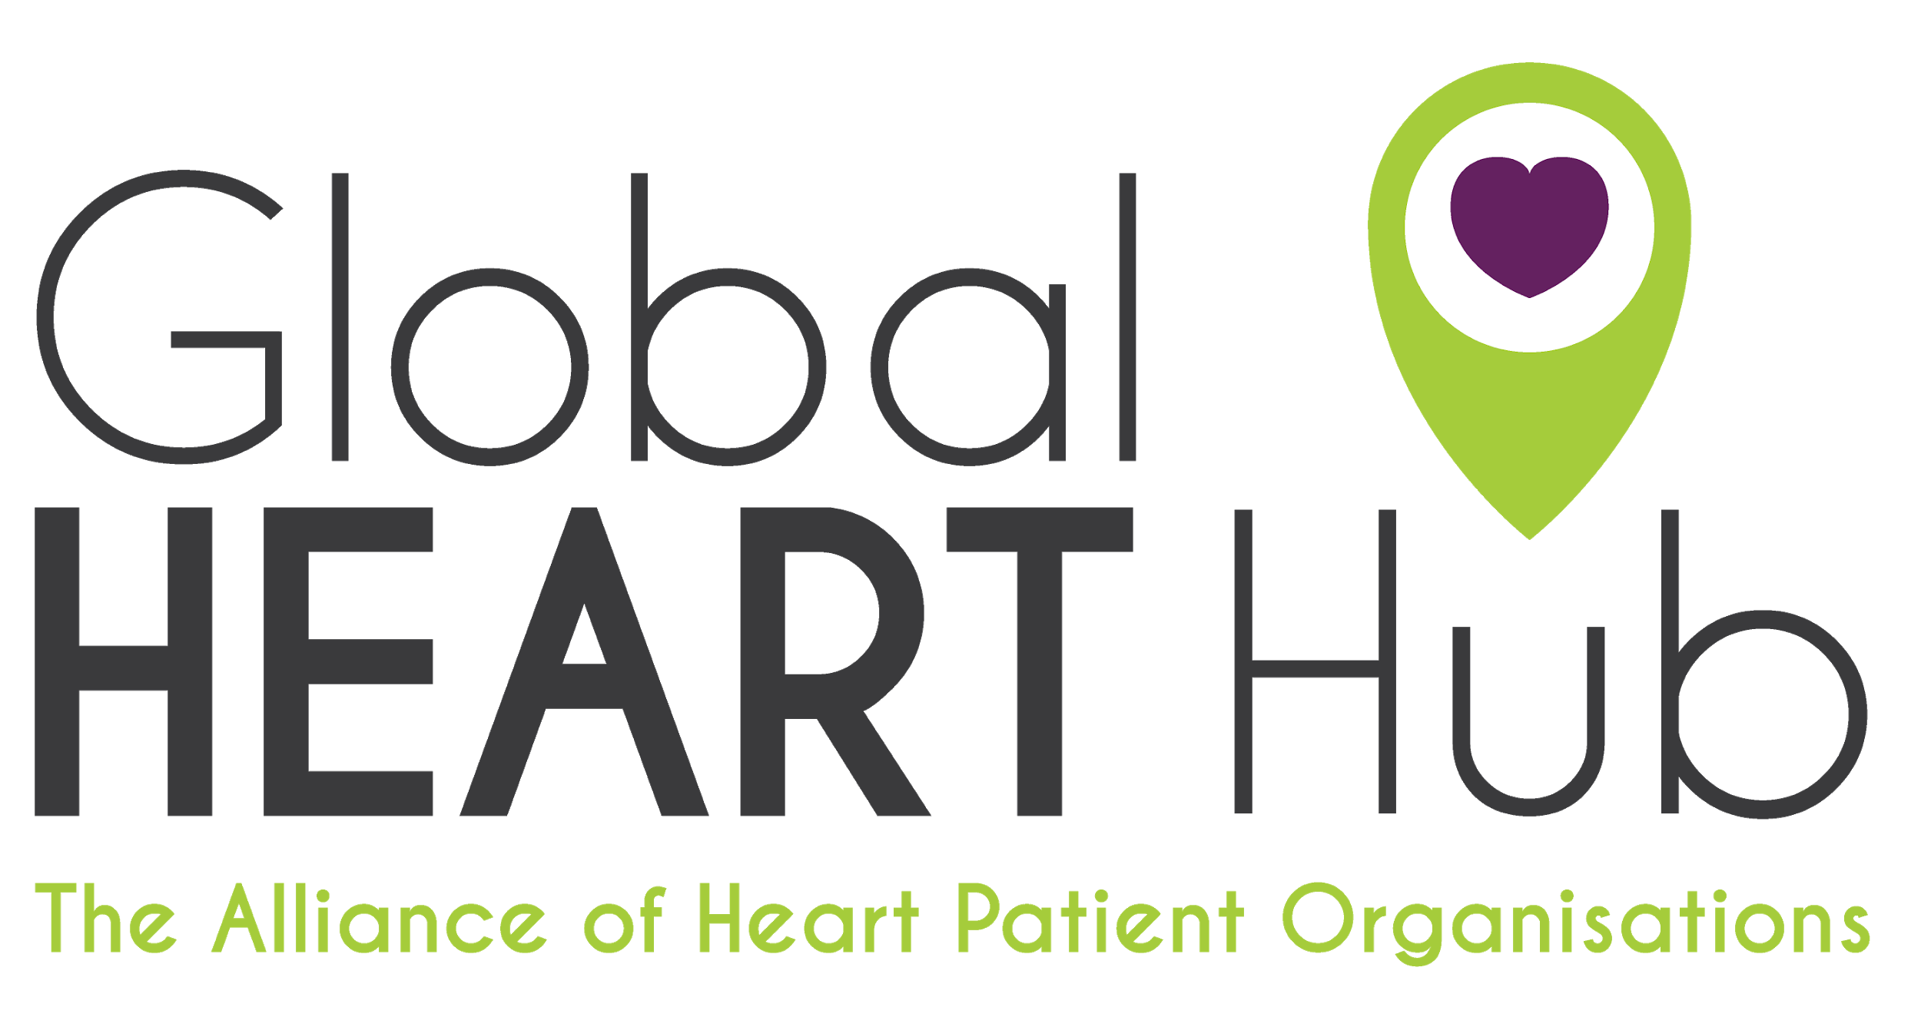
#JustGo Campaign | June 15 - July 31

Thank you for taking part in the #JustGo campaign. This campaign is an international collaboration between heart patient organisations aimed at saving lives and reducing disability by encouraging those with symptoms of heart or stroke emergency to seek medical help without delay.
The campaign is an initiative of the Global Heart Hub in partnership with FH Europe, a European patient network whose mission includes the prevention of early cardiovascular disease with a particular focus on familial hypercholesterolaemia (FH) and related conditions. Both organisations have joined forces on this patient-to-patient communications campaign to highlight the importance of seeking medical help for cardiac and stroke emergency during the COVID-19 crisis.

Sample editorial calendar for the #JustGo Campaign:
The below can serve as a guide and suggestions on what type of content you can post as part of this campaign. We recommend you share information relevant to your country, for example patient stories, support from clinicians, statistics from your hospitals, etc.

JUNE

Sunday | Monday | Tuesday | Wednesday | Thursday | Friday | Saturday
14 | 15  Launch of #JustGo campaign  - Share press release on your website if possible.  - Share key messages on social media using the graphics from the toolkit. | 16 | 17  #JustGo Signs and Symptoms  Share information around signs and symptoms for your patient network. | 18 | 19 | 20  #JustGo Patient Story  Share a patient story that links to the #JustGo key messages - example, a patient who experienced symptoms and went to the hospital despite fears of COVID-19 and had a positive outcome.
21 | 22 | 23  #JustGo  Share statistics from your country around the drop in patients presenting to hospital or their GP. Reinforce the #JustGo key messages. | 24 | 25  #JustGo Signs and Symptoms  Share information around signs and symptoms for your patient network.  Link back to your own website for more information. | 26 | 27  #JustGo  Share information on why are running this campaign - include reference to the GHH survey and the patient fear around going to hospital.
28 | 29  #JustGo Patient Story  Share a story from a healthcare professional that links to the #JustGo key messages - encouraging patients to not delay. | 30

JULY

SUNDAY | MONDAY | TUESDAY | WEDNESDAY | THURSDAY | FRIDAY | SATURDAY
28 | 29 | 30 | 1  #JustGo  Share information around what happens to your heart when you delay. Time = muscle | 2 | 3  #JustGo  Share statistics from your country around the drop in patients presenting to hospital or their GP. Reinforce the #JustGo key messages. | 4
5 | 6  #JustGo Patient Story  Share a patient story that links to the #JustGo key messages - example, a patient who experienced symptoms and went to the hospital despite fears of COVID-19 and had a positive outcome. | 7 | 8 | 9  #JustGo Signs and Symptoms  Share information around signs and symptoms for your patient network. Link back to your own website for more information. | 10 | 11
12 | 13 | 14  #JustGo  - Share key messages on social media using the graphics from the toolkit. | 15 | 16 | 17 | 18
19 | 20  #JustGo  - Share key messages on social media using the graphics from the toolkit. | 21 | 22 | 23 | 24 | 25
26 | 27 | 28  #JustGo  - Share key messages on social media using the graphics from the toolkit. | 29 | 30 | 31 | 1

